NAME: _______________________________________
Chapter 8.2 – A Growing Economy
Directions: Read “The Rise of New Industries” and “Ford, the Assembly Line, & Model T” on pp 212-12.
1. What evidence does the text use to support the idea that the economy of the 1920s benefited consumers and citizens?
____________________________________________________________________________________
____________________________________________________________________________________
2. How did the implementation of “mass production” & “the assembly line” benefit the US Economy?
____________________________________________________________________________________
____________________________________________________________________________________
3. What product created by Ford helped spur on economic growth in the 1920s?
____________________________________________________________________________________
4 In what other industries did Ford’s product boost demand?
____________________________________________________________________________________
Discussion – The Changing Economy
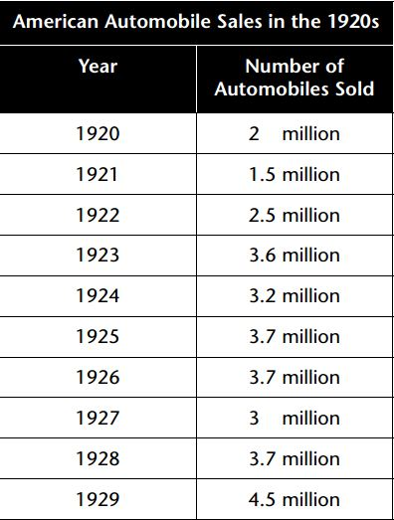
Directions: Read “The Consumer Economy” and “Consumer Credit” on pp214.
1. What is “Credit”?
____________________________________________________________________________________
____________________________________________________________________________________
2. Why do you think Americans during this time began to be more willing to use credit?
____________________________________________________________________________________
____________________________________________________________________________________

3. What dangers or risks do you think might come along with the use of credit?
____________________________________________________________________________________
____________________________________________________________________________________
Directions: Read “Mass Advertising” on pp215.
1. Why do you think the advertising industry grew and became important during the period?
____________________________________________________________________________________
____________________________________________________________________________________
2. What two ways did Advertisers use to encourage consumers to buy their products?
A)___________________________________________________________________________________
B)___________________________________________________________________________________

3. How do you think the growth of advertising and the use of credit might be connected?
____________________________________________________________________________________
____________________________________________________________________________________
Directions: Read “Uneven Prosperity” & The Farm Crisis” on pp215-6.
Group | Reason They Did Not Share in the Prosperity of the 1920s
African Americans
Native Americans
Immigrants
Southerners
Farmers

